

To: Corporate Management Team

Date: 29th July 2013

Report of: Head of Finance

Title of Report: Budget Monitoring as at 30th June 2013

Summary and Recommendations

Purpose of report: This report sets out the forecast outturn position for the Council’s Capital and Revenue budgets as at 30th June 2013 compared to the latest approved 2013/14 budget. In addition it provides information on key financial indicators in order to provide an assessment of the overall financial health of the organisation.

Key Decision: No

Executive lead member: Councillor Ed Turner

Policy Framework: Budget

Recommendations: That the City Executive Board;

1. Note the forecast outturn for the General Fund, Housing Revenue Account and Capital Programme.
2. Note the performance position.
3. Note the achievement of £0.796m of efficiencies, savings and additional fees and charges as at the end of June.

- Budget Monitoring as at 30th June 2013

Appendix A: June 2013 monitoring – General Fund Forecast Outturn
Appendix B: June 2013 monitoring – Capital Programme Forecast Outturn
Appendix C: June 2013 monitoring – Housing Revenue Account Forecast Outturn
Appendix D: June 2013 monitoring – General Fund year to date position

EXECUTIVE SUMMARY

- This report sets out the Council’s projected outturn position as at the 30th June 2013 and highlights major variances to the approved budget. In summary;

- The General Fund Revenue account shows a variation to the latest budget of £190k
- The HRA is similarly projecting an outturn position in line with the latest budget, although some movements relating to budgeted fees, together with identified mitigating action have been shown.
- The latest General Fund Capital outturn projection suggests a £0.125m favourable variance against the latest budget. This additional variation from approved budget relates to repairs to Blackbird Leys Pool which will now be deferred until the completion of the Competition Swimming Pool.
- The HRA Capital programme shows no variations as at the end of June to the latest budget.
- The collection rate for Council Tax arrears is 97.58% as at the end of June 2013, slightly up on May’s position of 97.44% and the cumulative year-end position for 2012/13 of 97.01%.
- The collection rate for Business Rates arrears is 97.73% as at the end of June 2013, slightly up on May’s position of 97.51% and the cumulative year-end position for 2012/13 of 97.04%.
- The payment of invoices within 30 days now stands at 96.54%, the target for the year is 97%. The performance in June improved and stood at 97.21%.
- HRA total arrears were £1.250m as at the end of June, they were £1.017m for the same period 12 months ago. HRA total arrears were £1.263m at the end of April.

- The Approved budgets have been re-aligned to reflect virement requests approved by the Head of Finance/Council up to June in accordance with the Council’s Financial Regulations. The value of which totals £0.758m the majority of which, £0.712m, relate to movement of resources between earmarked reserves/contingencies and revenue budgets.

- As part of the monitoring process Finance staff have met and had budget monitoring discussions with Cost Centre Managers and Heads of Service to verify the current budgetary position. The following forecast variances have been identified and these are commented on and explained more fully within the body of the report.

GENERAL FUND OUTTURN

- Appendix A sets out the General Fund revenue outturn position as at the end of June 2013, broken down by Service Area. Table 1 overleaf details the summarised General Fund position.

- Table 1 General Fund Revenue

GF Outturn Report 13/14 @ Q1 - 30th June, 2013 | Approved Budget (per Budget book) | Virements | Latest Budget | Projected Outturn @ Q1 30th June,2013 | Outturn Variance
 | £000's | £000's | £000's | £000's | £000's
Directorates
City Regeneration | (283) |  | (244) | (135) | 109
Community Services | 8,296 | 155 | 8,834 | 8,834
Organisational Dev & Corp Services | 13,066 | 603 | 13,730 | 13,811 | 81
Directorate Total Excl SLA's & Capital Charges | 21,079 | 758 | 22,319 | 22,509 | 190
SLA's & Capital Charges | (1,182) |  | (1,184) | (1,184)
Corporate Accounts | 2,793 |  | 2,951 | 2,951
Contingencies | 2,336 | (46) | 2,167 | 2,167
Total Corporate Accounts & Contingencies | 5,130 | (46) | 5,119 | 5,119
Net Expenditure Budget | 25,027 | 712 | 26,254 | 26,444 | 190
Transfer to / (from) Ear Marked Reserves |  | (712) | (1,227) | (1,227)
Net Budget Requirement | 25,027 | () | 25,027 | 25,217 | 190
Funding
External Funding (RSG) | 8,219 |  | 8,219 | 8,219
External Funding (NNDR Retention) | 5,661 |  | 5,661 | 5,661
Council tax | 11,228 |  | 11,228 | 11,228
Less Parish Precepts | (154) |  | (154) | (154)
Collection Fund Surplus | 73 |  | 73 | 73
Total Funding Available | 25,027 |  | 25,027 | 25,027
(Surplus) / Deficit for year |  | () | () | 190 | 190

- City Regeneration Directorate - The Directorate is currently estimated to have a projected outturn position of £0.135m. This is adverse against the latest budget position by £0.109m. This has been caused by additional costs associated with in-year re-structures, the inability to deliver planned efficiencies in Corporate Property (albeit this is intended to be mitigated by increased commercial property income – see efficiencies section below), additional projected spend linked with a variety of projects including Westgate, Barton, City Deal and Oxpens. There are a number of options being proposed how this additional spend can be funded and these are explained in more detail in the following paragraphs. The position is further compounded by income concerns associated with Building Control income.

- City Development is encountering a continuation of the income issues reported in 2012/13, relating to Building Control Fees. Previous concerns relating to Planning Fees have reduced based on recent applications that suggest that this position has improved and no adverse year-end projections are now being predicted. There are number of other budgetary pressures totalling £46k and these are listed below including £240k to fund posts which are essential for advising on a number of key Council projects. These posts will be funded from capital grants and therefore the overall effect on the net revenue budget will be zero.

Item of Spend | £ | Funded by:
Building Control Fees under-recovery | 40,000 | -
Non-achievement of Efficiency Savings | 6,000 | -
Partnership and Regeneration Manager | 90,000 | New Growth Points Grant
Regeneration Assistant (1 FT or 2 PT) | 50,000 | New Growth Points Grant
Oxpens and the Station Consultancy Works | 100,000 | HCA Oxpens Capital Grant
Total | 286,000
Less funded from capital grant | 240,000
Net forecast overspend | 46,000

- Corporate Property is projecting an adverse variance at year-end and this is detailed as follows:

Item of Spend | £ | Funded by:
2 x Surveyor Posts (Investement Surveyor/Senior Development Manager) | 63,000 | The gross cost is £100,000; however this is being partly offset by £37,000, being the difference between the budgeted HoS post and the new Service Manager post.
Non-achievement of Efficiency Savings | 100,000 | It is anticipated that this may be covered by additional rent realised in-year from the Council’s commercial property portfolio.
NNDR Payable on Barton Centre | 10,000 | It is anticipated that this may be covered by additional rent realised in-year from the Council’s commercial property portfolio.
Additional Rent from Commercial Portfolio | (110,000) | As above.
Total | 63,000

- Increased income from rent reviews from the position originally budgeted for 2013/14 is anticipated and should cover the non-achievement of efficiencies and additional NNDR spend mentioned above..

- GF Housing is experiencing some increased activity in Home Choice Private Sector Leasing (PSL) activity, which is improving income levels from reduced void periods. However, if the number of approved homelessness applicants continues to rise as has been experienced so far this year then increased short stay overnight expenditure, which is the most expensive, will create further budgetary pressures. However, because the authority has provided a £0.400m Homelessness contingency for 2013/14 no adverse variance on the revenue account is being predicted at this stage. In addition other mitigations are being put in place to assist with relieving the pressure.

- Community Services Directorate - The Directorate is currently estimated to have a projected outturn position of £8.834m. There have been some budget virements between service areas during the period to June but no year-end projected variances are anticipated as at the end of June.

- The Policy, Culture and Communication service area has now been incorporated within the Community Services Directorate and is projected to have an end of year outturn position of £1.350m. There are no year-end variances shown based on the position as at the end of June.

- Leisure and Parks have absorbed the Communities budgets for the year following the management review to have the Service Head of Leisure and Parks now oversee these areas. No projected year-end variances are being reported for June.

- Direct Services are similarly showing no projected year-end variance, however, there has been a number of pressure areas, together with mitigating action and these are detailed below;

Budget Pressures %age
Of total
- NNDR uplifts on Direct Services buildings - £0.100m 9
- Non-achievement of Horspath Rd Depot rental saving - £0.116m 100
- Motor Transport under recovery - £0.185m 5
£0.401m
Mitigating Action

- Vacancies and over budgeting on Pensions - £0.200m 7
- Motor Transport Auction - £0.050m n/a
- Additional car park income - £0.050m 0.6
- Alleygating work won by Streetscene Service - £0.101m 50
£0.401m

- Organisational Development and Corporate Services Directorate - The Directorate is currently estimated to have a projected outturn position of £13.811m with an adverse variance in the order of £81k predicted as at the end of June.

- All service areas save for Human Resources and Facilities, are projecting a nil year-end variance against their latest budget position.

- With regards to Human Resources and Facilities the issues creating the £0.081m adverse year-end projection relate to the early termination for the vending machine contract, namely £0.030m. Café fees of £0.024m as a concession to get the facility up and running again following the difficulties associated with the previous contractor. Additionally there are, post room income recharges pressures of £0.027m.

CORPORATE ACTIVITIES

- No year-end variations to the latest budget positions are known for the items within Corporate Accounts and Contingencies as at the end of June.

ACHIEVEMENT OF SAVINGS AND EFFICIENCIES

- The Council’s budget identifies £1.320m of efficiencies, £0.183m of service reductions and £1.692m of additional income for 2013/14. As at the end of June it is anticipated these will be delivered with the following exceptions:

Efficiencies

- Corporate Property - £0.100m employee savings and £0.030m additional income from Gloucester Green market. However, increased income from the commercial property portfolio is anticipated to mitigate these exceptions.

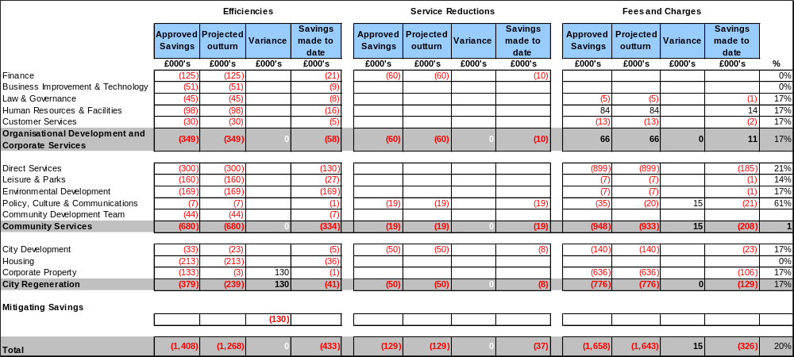
Table 2 – Savings and Efficiencies as at 30th June 2013

CONTINGENCIES, RESERVES AND BALANCES

- Within the approved General Fund budget for 2013/14 the Council has provided £2.793m of corporate accounts that effectively are items of income and expenditure not specific to a particular service area. They are as follows:

    - Net cost of Housing Benefits £ 0.200m
    - Support service charges to the Corporate Services £ 3.483m
    - HRA Interest Receivable £ (6.789m)
    - Depreciation and revenue funding of capital £ (0.434m)
    - Investment Income £ (0.467m)
    - Interest Payable £ 7.114m
    - New Homes Bonus £ (1.685m)

- Approved transfers to contingencies amount to £2.336m and are listed below:

    - Pensions Provisions Top Up Contingency £ 0.168m
    - Provisions for Pressures, Recessions, High Risks £ 1.468m
    - Homelessness Contingency £ 0.400m
    - Redundancy Costs Contingency £ 0.250m
    - Disabled Transport Contingency £ 0.050m

- No other changes to existing corporate accounts, growth bids and contingencies are expected at this early stage of the year.

- There has been £0.712m of transfers from earmarked reserves during the period to the end of June mostly in connection with funding for transformation projects

HRA OUTTURN

- The summarised HRA position as at 30th June 2013 is set out in Table 3 and detailed in the attached Appendix C. The table below exemplifies the major movements commented on in the following paragraphs.
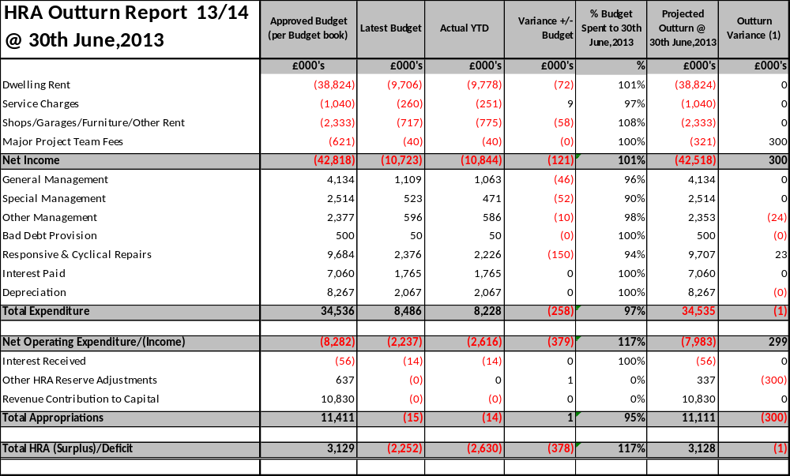
Table 3 – Housing Revenue Account HRA

Income

- Dwelling rents are £0.072m more than projected for the end of June. As at the end of June the authority had experienced 5RTB disposals.

- It was agreed that £0.300m of the Major Project Team capital fees would be accommodated from HRA balances in 2013/14. For 2014/15 onwards it has been agreed that the Head of Housing, with the assistance of the Head of Direct Services will work together and provide a proposal to mitigate the budgetary impact of these changes and report back as part of the 2014/15 budget process to be agreed in February 2014.

Expenditure

- No year-end variances are projected as at the end of June.

Appropriations

- The £0.300m favourable outturn position reported in the Appropriations section is the funding from balances mentioned above.

CAPITAL PROGRAMME

General Fund and HRA Capital Programme

- A capital budget position, approved for the General Fund and HRA Capital Programme for 2013/14 is shown in summary at Table 4 below. Appendix B attached shows the Capital Programme on a scheme by scheme basis.

- As at the end of June the Capital Programme shows a favourable variance of £0.125m against the latest budget. This relates to the planned Blackbird Leys Leisure Centre Improvements that will be slipped as it is linked with the new pool development that has been delayed.

- This is on top of previous month’s slippages/underspends associated with the following schemes and reported in May’s monitoring report.

- Feasibility Study Depot Relocation £ (1.880m) – this project has been deferred and the project slipped into 2014-15
- New Pool £ (3.500m) – slippage due to Judicial review
- New Burial Space £ (0.900m) – re-profiled spend only £0.100m in 2013/14
- Carbon Reduction £ (0.300m) – not capital works

Table 4 – Capital Programme as at 30th June 2013

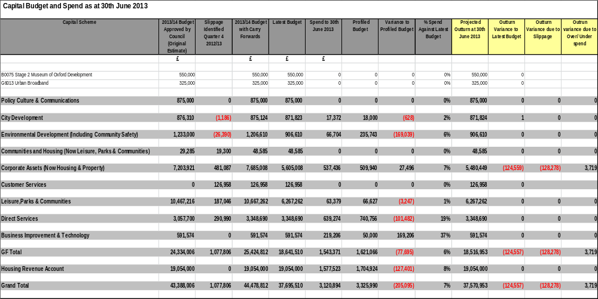

PERFORMANCE INFORMATION

- There are a number of additional key performance indicators that need to be assessed along with the financial performance information to provide an overall financial health check position for the authority as at the end of June 2013. These additional indicators are detailed as follows:

Investment Performance
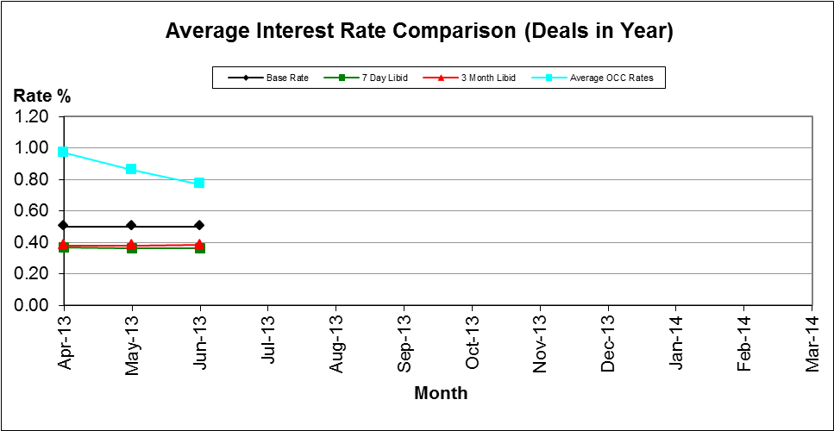
- The average rate earned in the first quarter is declining, this is due to a number of longer term high rated loans that have now matured and been replaced with fixed term loans at a much lower rate. We are still above our benchmark of 7 day LIBID, but not yet reaching our performance target of 0.50% above base. We are looking at different opportunities for our investments in the aim to increase our interest earned and keep our average rate up.

Creditor Payment Times

- During June 2013 the percentage of creditor invoices paid on time was 97.21% compared to the target of 97%. The cumulative position for the year is slightly lower at 96.53%.

Table 5 – Creditor Invoice Payment Performance by Service Area as at 30th June 2013

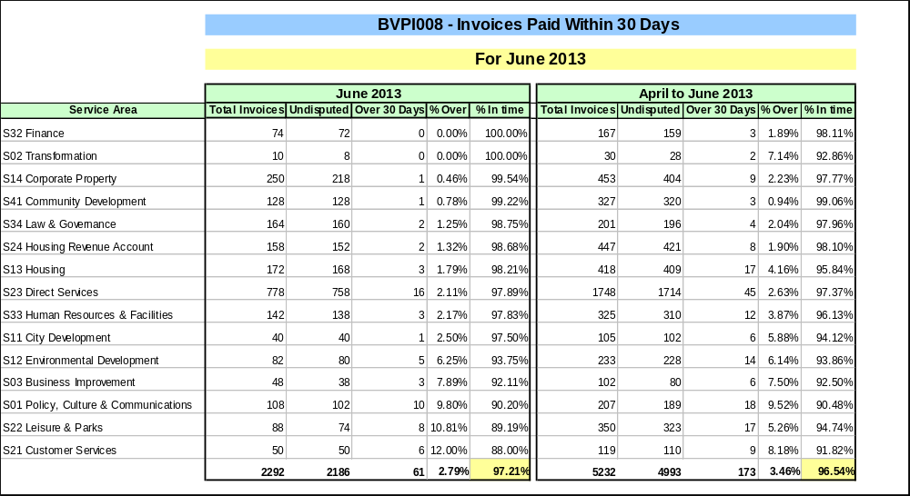

Housing Benefit Overpayments

- The overall total of HB Overpayments arrears increased during June from £4.592m to £4.617m, an increase of £0.025m in the month. New HB Overpayments identified and raised during June totalled £0.244m, with a total of £0.219m overpayments being recovered through either deductions and/or future offsets from on-going Housing Benefit entitlement and actual payments. Current collection rate is 81.37%, which is just below this year's target of 82%.

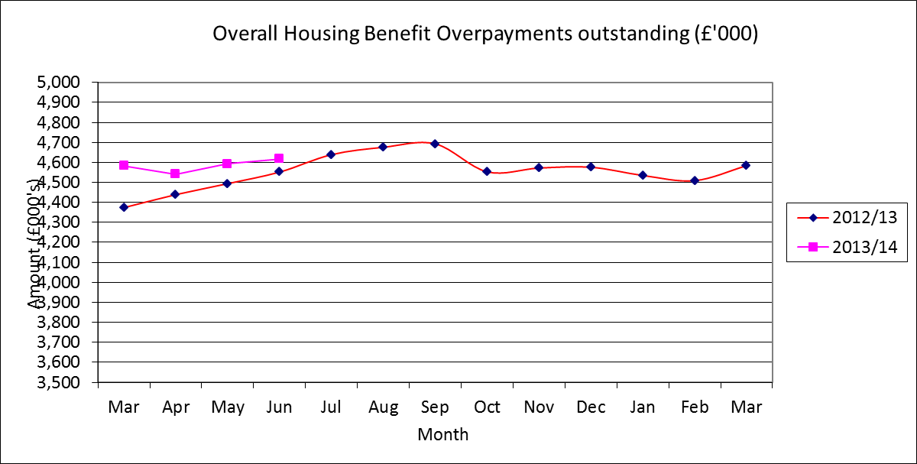

Business Rates

- The arrears total at the beginning of the 2013/14 financial year was £3.409m.This figure is £0.081m or 2.3% lower than the total arrears 12 months earlier.

- During June arrears fell by £0.267m. Payments received totalled £0.302m but refunds amounted to £0.367m. These mainly resulted from credit adjustments that totalled £0.336m.

- The collection rate of 97.04% for 2012/13 had moved to 97.73% as at the end of June 2013. The 2013/14 cumulative collection rate was 32.16% at as the end of June. This was up on last year's equivalent of 32.10%. In monetary terms the position at the end of June was £0.138m up on our profiled collection target of 32% for the end of the first quarter.

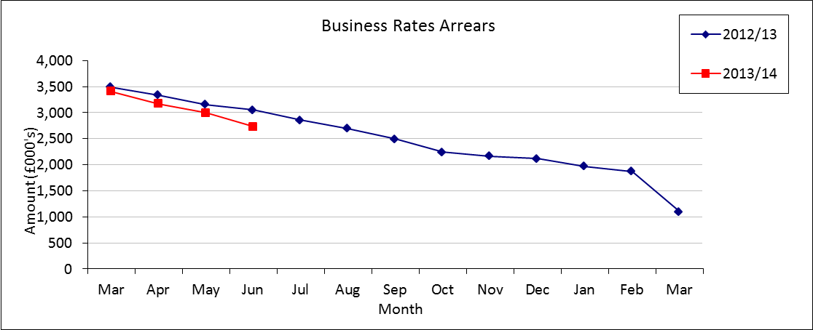

Council Tax Arrears Collection

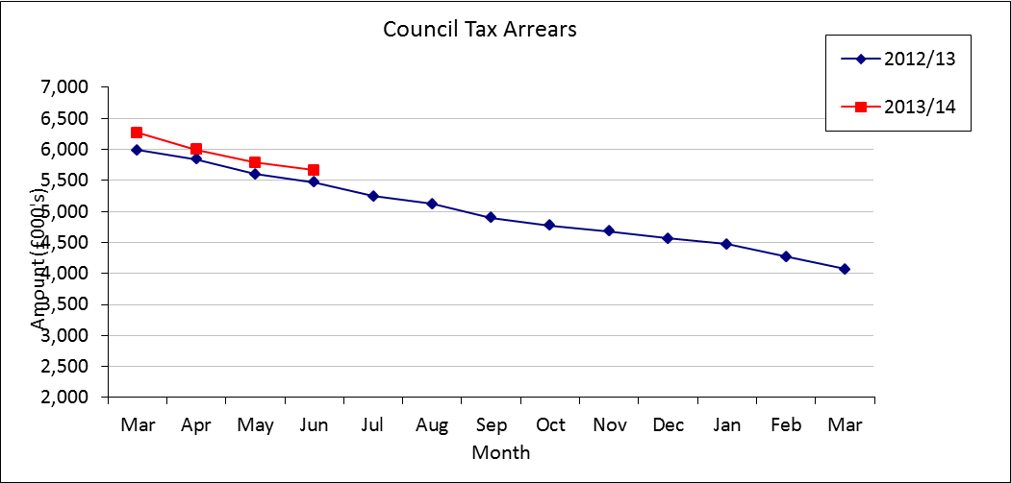

- The Council Tax arrears carried forward from 2012/13 were £6.269m, being a 4.7% increase on the corresponding figure 12 months earlier. This total included outstanding Court Costs of £0.574m.

- During June the arrears fell by £0.125m. Payments received during the month were £0.140m but a total of £0.020m was refunded. Debit adjustments, namely retrospective discounts, exemptions etc., amounting to £0.018m were granted during the month.

- The cumulative collection rate for 2012/13 had moved on from 97.01% at the beginning of the financial year to 97.58% at the end of June 2013.

- The 2013/14 cumulative collection rate at the end of June was 30.55%, which was slightly up on last year's equivalent position of 30.36%. In cash collection terms we were £0.033m up on the profiled collection target for June of 30.50%.

Housing Rent Arrears

- Analysis of current and former tenant rent arrears is shown below for the 12 month period ending 30th June 2013.

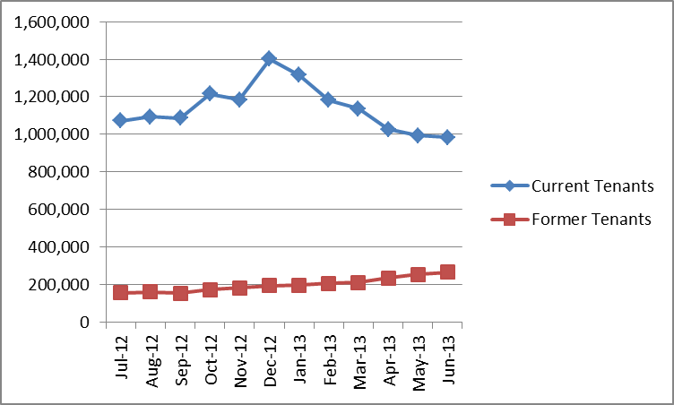
Analysis 1 - HRA Rent Arrears Current Tenants and Former Tenants
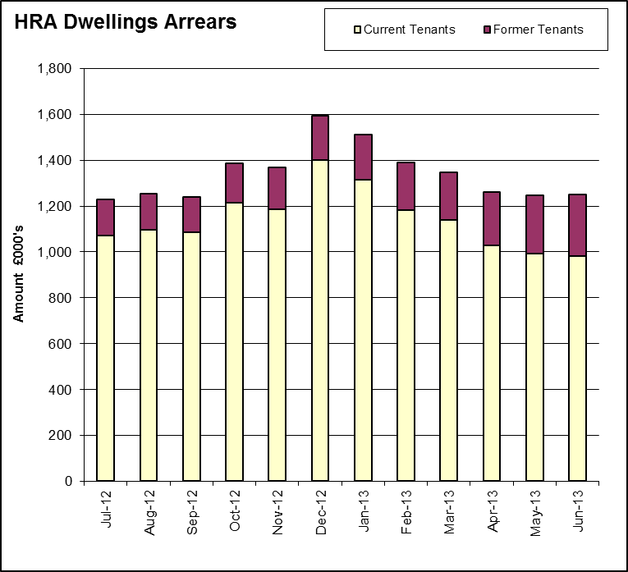
Analysis 2 - HRA Rent Arrears Current Tenants and Former Tenants

- Total arrears (dwellings, garages and Rechargeable Repairs) stands at £1.250m, an increase on last month’s position of £0.002m.

- Former tenant arrears stood at £0.266m as at the end of June 2013, which is £0.032m higher than that reported for April. This has occurred as a result of several tenants that have recently vacated their property and doing so with substantial arrears associated with their rent accounts. Former tenant arrears are £0.134m higher than 12 months ago, an increase of 101%.

- The Council has estimated an HRA bad debt provision of up to £0.500m in 2013/14 is available to write off HRA debts for rents, garages and rechargeable repairs.

Name and contact details of author:-
Name: Nigel Kennedy
Job title: Head of Finance
Service Area / Department Finance and Efficiency
Tel: 01865 272708 e-mail: nkennedy@oxford.gov.uk

